THE BARMONEY STANDING STONES, WEXFORD
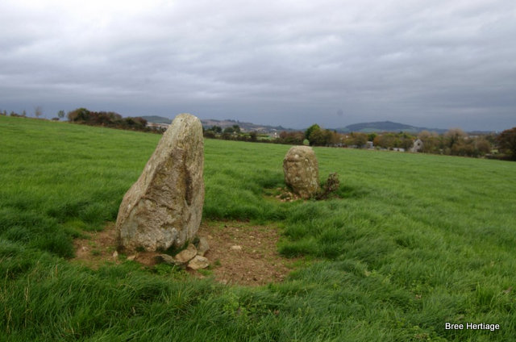
The Barmoney standing stone pair (WX 031-039) are located in a large pasture field on the side of a low ridge, which rises to the west. They are situated a short distance to the south of the Kilcowenbeg holy well (031-038003) and on the first edition Ordnance Survey map the stones are recorded as a ‘Druid’s altar’. They consist of two quartz-bearing granite stones placed circa 4.20m apart and aligned roughly northeast – southwest. The smaller northern stone measures 0.8m by 0.45m by 1m high, while the larger southern stone measures 0.55-0.7m by 0.7m by 1.35m high. Looking northeast the stone pair appear to be aligned on a point just east of Bree hill, while to the southwest they are focused on the horizon.
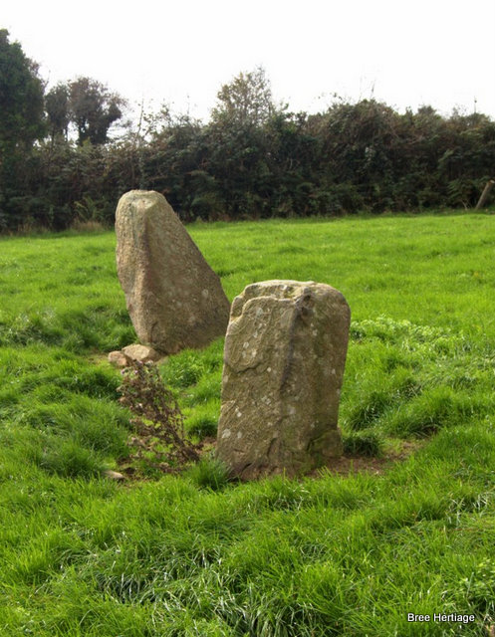Barmoney standing stones
The majority of stone pairs are found in the southwest of Ireland, with over 100 pairs being identified in counties Cork and Kerry. They are generally orientated southwest-northeast, which mirrors the Barmoney stones. Research suggests that these monuments were probably erected sometime during the Bronze Age (2500-500BC). In Wexford the stones at Barmony represent the county’s only prehistoric stone pair, although a stone row, which appears to be a related monument type, is also known from Whitechurch, near New Ross. The original function of these monuments remains uncertain, but it is possible that they were used to define celestial events and helped mark important points in the farming calendar

